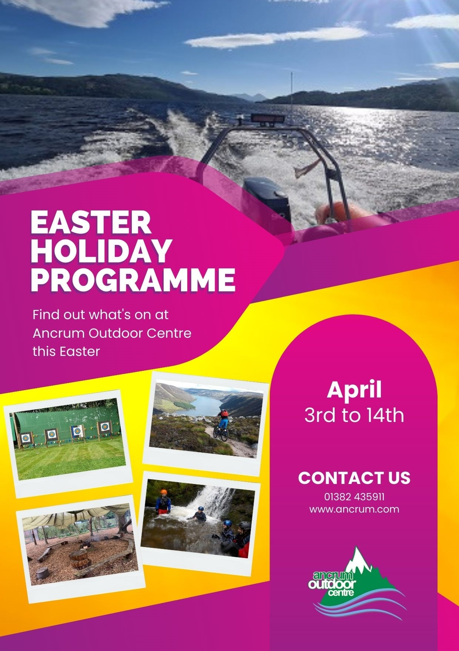
Find out what’s happening at Ancrum during the April school holidays

Activity | Multi Activity Day (16 spaces)
Meeting Place | Ancrum Outdoor Centre - 9am registration, Pick up 4.30pm-4.45pm latest
Date | Monday 3rd April 2023
Price | £35
Age | Suitable for 8-16 years
Description | Come and enjoy taking part in a few of our favourite adventure Activities locally. This will include beginner ski lesson + sledging at our dry slope at our HQ followed by target archery and bushcraft activities at Clatto Barns Activity Centre. Activities can change depending on weather and may include a tree climb.
Activity | Easter Holiday Cycle Ride (14 spaces)
Meeting Place | 9.30am to 3pm. Drop off and pick up point: Bridgeview Station Restaurant Car Park, Riverside Drive, Dundee DD1 4DB
Date | Monday 3rd April 2023
Price | £20
Age | Suitable for 8-13 years
Description | Come and join us for a led ride from the Bridgeview Station Restaurant to Broughty Ferry Castle and back on a cycle path. On the top of that we will do some Team Building games like Big Feet, Gutter Ball, Tug of War at the playground in front of the Castle.  Requirements: Ability to ride a bike  Equipment: You are welcome to bring your own however we can provide helmets and bicycles.  Packed lunch required for the day and pocket money for an ice cream is optional.
Acitivity | Mountain Biking Day (10 spaces)
Meeting Place | Ancrum Outdoor Centre - 9am registration, Pick up 4.30pm-4.45pm latest
Date | Tuesday 4th April 2023
Price | £40
Age | Suitable for 11-16 years
Description | Improve your riding skills at a really cool venue used by our Centre. This will be a great day out in forests and scenic locations to give you a real sense of adventure. We provide all bikes and equipment/clothing required.
Activity | Mountain Biking Day (10 spaces)
Meeting Place | Ancrum Outdoor Centre - 9am registration, Pick up 4.30pm-4.45pm latest
Date | Tuesday 4th April 2023
Price | £40
Age | Suitable for 8-11 years
Description | Improve your riding skills at a really cool venue used by our Centre. This will be a great day out in forests and scenic locations to give you a real sense of adventure. We provide all bikes and equipment/clothing required

Activity | EICA Indoor Climbing Day (14 spaces)
Meeting Place | Ancrum Outdoor Centre - 9am registration, Pick up 4.30pm-4.45pm latest
Date | Wednesday 5th April 2023
Price | £40 including entry fee
Age | Suitable for 8-15 years
Description | Thrilling fun for everyone. A great adventure is waiting inside Europe’s biggest climbing arena.
Activity | Easter Holiday Cycle Ride (14 spaces)
Meeting Place | 9.30am to 3pm. Drop off and pick up point: Bridgeview Station Restaurant Car Park, Riverside Drive, Dundee DD1 4DB
Date | Thursday 6th April 2023
Price | £20
Age | Suitable for 8-13 years
Description | Come and join us for a led ride from the Bridgeview Station Restaurant to Broughty Ferry Castle and back on a cycle path. On the top of that we will do some Team Building games like Big Feet, Gutter Ball, Tug of War at the playground in front of the Castle.  Requirements: Ability to ride a bike  Equipment: You are welcome to bring your own however we can provide helmets and bicycles.  Packed lunch required for the day and pocket money for an ice cream is optional.
Activity | Coastal Caves and Bushcraft Day (10 spaces)
Meeting Place | Ancrum Outdoor Centre - 9am registration, Pick up 4.30pm-4.45pm latest
Date | Thursday 6th April 2023
Price | £35
Age | Suitable for 8-14 years
Description | This day is for real explorers wanting to learn about wildlife and learn bushcraft survival skills in the amazing Arbroath coastline caves. Only book on if you’re not scared of the dark!
Activity | Rock Weaselling and Tyrolean Day (14 spaces)
Meeting Place | Ancrum Outdoor Centre - 9am registration, Pick up 4.30pm-4.45pm latest
Date | Friday 7th April 2023
Price | £40
Age | Suitable for 8-14 years
Description | Weaselling involves taking a rock hopping scrambly route through jumbles of gritstone boulders. It is great fun and the perfect activity. Be a weasel with us then test your head for heights when you help build your very own flying fox Tyrolean…

Activity | Tyrolean + Climbing + Archery
Meeting Place | Ancrum Outdoor Centre - 9am registration, Pick up 4.30pm-4.45pm latest
Date | Monday 10th April 2023
Price | £40
Age | Suitable for 8-14 years
Description | Build your very own zip line at Balgay Park followed by outdoor climbing experience on our tree climb or mobile wall and if weather is not so nice we shall visit a local indoor climbing arena in Dundee and finish off with target archery competition. This is a day for real adventurers with no fear!
Activity | Easter Holiday Cycle Ride (14 spaces)
Meeting Place | 9.30am to 3pm. Drop off and pick up point: Bridgeview Station Restaurant Car Park, Riverside Drive, Dundee DD1 4DB
Date | Monday 10th April 2023
Price | £20
Age | Suitable for 8-13 years
Description | Come and join us for a led ride from the Bridgeview Station Restaurant to Broughty Ferry Castle and back on a cycle path. On the top of that we will do some Team Building games like Big Feet, Gutter Ball, Tug of War at the playground in front of the Castle.  Requirements: Ability to ride a bike  Equipment: You are welcome to bring your own however we can provide helmets and bicycles.  Packed lunch required for the day and pocket money for an ice cream is optional.
Activity | Coastal Caves and Bushcraft Day (12 spaces)
Meeting Place | Ancrum Outdoor Centre - 9am registration, Pick up 4.30pm-4.45pm latest
Date | Tuesday 11^{h} April 2023
Price | £35
Age | Suitable for 8-14 years
Description | This day is for real explorers wanting to learn about wildlife and learn bushcraft survival skills in the amazing Arbroath coastline caves. Only book on if you’re not scared of the dark!
Activity | Multi Activity Adventure Day
Meeting Place | Ancrum Outdoor Centre
Date | Wednesday 12th April 2023
Price | £40
Age | Suitable for age 8-14 years
Description | Come and enjoy taking part in a few of our popular adventure activities locally which will include Mountain Biking, Tree Climb, Bushcraft and Target Archery, You MUST be able to ride a bike confidently for this adventure day!

Activity | Elie Chainwalk Day (8 spaces)
Meeting Place | Ancrum Outdoor Centre - 9am registration, Pick up 4.30pm-4.45pm latest
Date | Thursday 13 April 2023
Price | £40
Age | Suitable for 8-12 years
Description | Chain walking is an exciting and unique activity provided by Ancrum Outdoor Centre which takes place in Elie on the Fife coastal path. The route challenges participants (equipped with harnesses and helmets) to journey on a section of this path by means of walking, scrambling and moving across steep sections with the aid of chains bolted on to the cliff face. This is a popular activity so book up fast.
Activity | Easter Holiday Cycle Ride (14 spaces)
Meeting Place | 9.30am to 3pm. Drop off and pick up point: Bridgeview Station Restaurant Car Park, Riverside Drive, Dundee DD1 4DB
Date | Thursday 13th April 2023
Price | £20
Age | Suitable for 8-13 years
Description | Come and join us for a led ride from the Bridgeview Station Restaurant to Broughty Ferry Castle and back on a cycle path. On the top of that we will do some Team Building games like Big Feet, Gutter Ball, Tug of War at the playground in front of the Castle.  Requirements: Ability to ride a bike  Equipment: You are welcome to bring your own however we can provide helmets and bicycles.  Packed lunch required for the day and pocket money for an ice cream is optional.
Activity | Canoeing Day (12 spaces) – weather dependent
Meeting Place | Ancrum Outdoor Centre - 9am registration, Pick up 4.30pm-4.45pm latest
Date | Friday 14 April 2023
Price | £35
Age | Suitable for 8-14 years
Description | We shall take you to a beautiful freshwater loch or on a popular river trip to go out in the water on a canoeing journey to explore where only boats can go. Our instructor will teach you everything you and your crewmate need to do with paddles to get there and maybe stay dry!  **Please note that if weather is unsuitable for Canoeing our lead instructors shall allow participants to vote from a list of alternatives adventure days and most popular vote shall apply. **

