Ancrum Outdoor Centre
Activity information sheet
Blo-karts  This activity has been described as equivalent to go-karting on sand. Learn the skills of operating these fantastic wind powered buggies and use the laws of physics to get wind in your sail to cruise along the west sands of St Andrews beach. Only thing is…the weather, wind and tide have to be right for you to experience this thrilling activity.  By taking part in this activity, I will learn:  - About coastal environment, tides and weather  - The science of wind power  - New skills to drive the Blo-Kart  - About working independently or with team mate  - How to Risk Assess any dangers involved  - How well I can listen to and follow instructions  Follow this link to see them in action:  https://www.youtube.com/watch?v=4wxn9C82QGs | 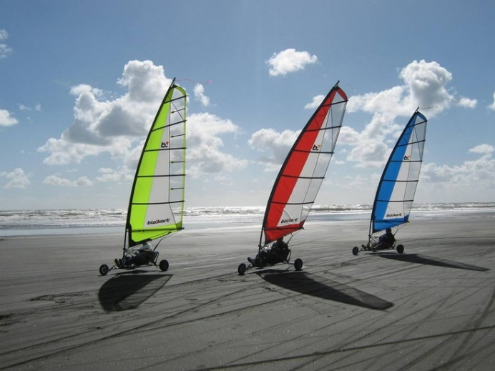
Climbing/Abseiling  https://www.youtube.com/watch?v=GOZqUqze4kk  At a nearby rock face or indoor wall we will teach you how climb on short climbing crags. These will vary in difficulty but we’ll take you to a place that suits your level of ability. Climbing has been described as 3 dimensional chess, with the rock being the board and you are the chess piece.  Other types of climbing might be tree climbing or scrambling along rocks.  During this activity I will learn:  - About rock formation and erosion  - How to climb rocks safely and effectively.  - Solve problems  - About working with team mate/s  - How to Risk Assess any dangers involved  - How well I can listen to and follow instructions | 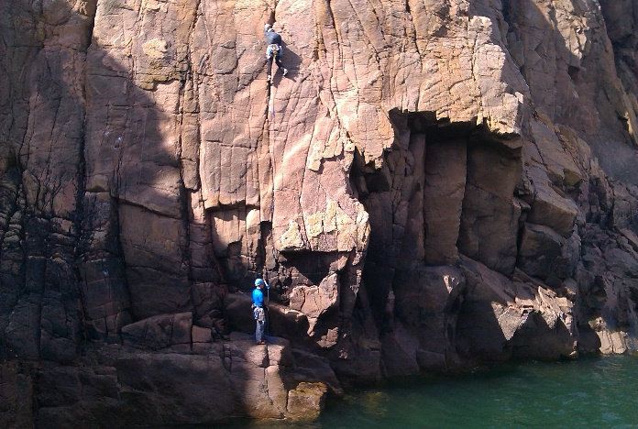
Coasteering  This activity is by far the most adventurous experience and is always a favourite with our groups. We shall head to a local coastline, exploring the caves, climbing over the rocks, adventure swimming in the waves, jumping into the sea and sliding down the rock chutes.  By taking part in this activity, I will learn:  - About coastal environment, tides and weather  - The wildlife of this ever changing wild habitat  - About working together as a team  - Leadership and responsibilities in this wild environment  - How to Risk Assess any dangers involved  - How well I can listen to and follow instructions  - How to cooperate to help each other along.  - How to overcome fears.  Follow this link for some video action:  https://www.youtube.com/watch?v=v55uf1BjZP8 | 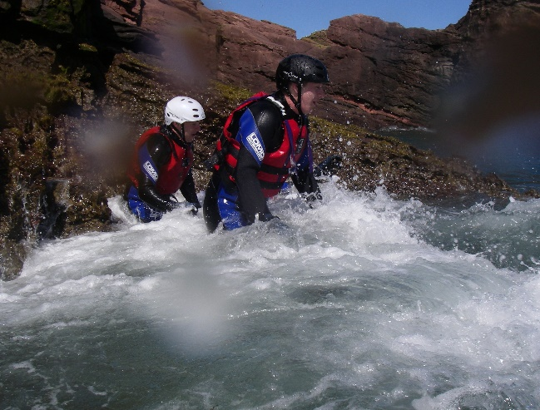
Elie Chain Walk  This is a most unusual trail along the Fife Coastal Path that involves going on a journey along the coastline…without getting wet!. You will put on a climbing harness at the start and at times attach yourself to the chains built into the cliff face and navigate and explore areas that are normally out of reach and unseen from the normal coastal path. There are also lots of geological features and historic areas to see.  By taking part in this activity, I will learn:  - About coastal environment, tides and weather  - Historic facts  - About some natural features on the rocks that we call geology.  - The wildlife of this ever changing wild habitat  - About working together as a team  - Leadership and responsibilities in this challenging environment  - How to Risk Assess any dangers involved  - How well I can listen to and follow instructions  - How to cooperate to help each other along.  - How to overcome fears.  Have a look at it here:  https://www.youtube.com/watch?v=9jaXAD_Nl_4 | 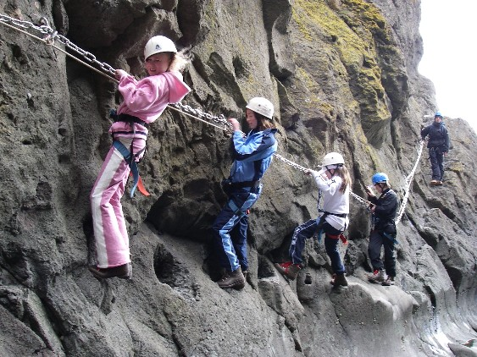
Gorge Walking  We shall venture down a small burn/stream playing in the natural water features on the journey. You will get kitted in wetsuit gear like those in the picture and we will take you on a journey from the top of the river all the way down stream. So, prepare to walk ankle deep, knee deep and wait for it maybe neck deep as you navigate by sliding, jumping and swimming your way down the gorge. Even those who can’t swim very well have a great time on this activity.  By taking part in this activity, I will learn:  - About river environment and weather  - Features in a river and about river hydrology.  - Some natural rock features- geology.  - The wildlife of this habitat  - About working together as a team  - Leadership and responsibilities in this challenging environment  - How to Risk Assess any dangers involved  - How well I can listen to and follow instructions  - How to cooperate to help each other along.  - How to overcome fears.  Follow this link to see this in action:  https://www.youtube.com/watch?v=ktdT2FUZJ4w | 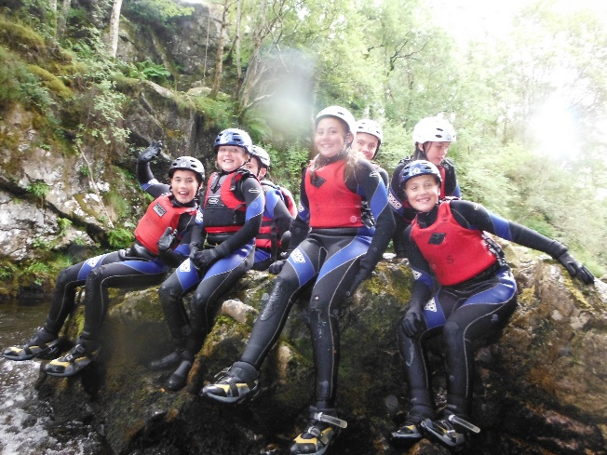
Kayaking/Canoeing and paddleboards  Get your wetsuit gear on and get ready to paddle your very own craft solo or team up with a partner in one of the canoes and journey around some of our local lochs and rivers.  By taking part in this activity, I will learn:  - About the loch environment  - Historic facts  - The wildlife of this wild habitat  - About working together as a team  - Leadership and responsibilities in this challenging environment  - Learning new skills in boat handling  - How to Risk Assess any dangers involved  - How well I can listen to and follow instructions  - How to cooperate to help each other along.  - How to overcome fears. | 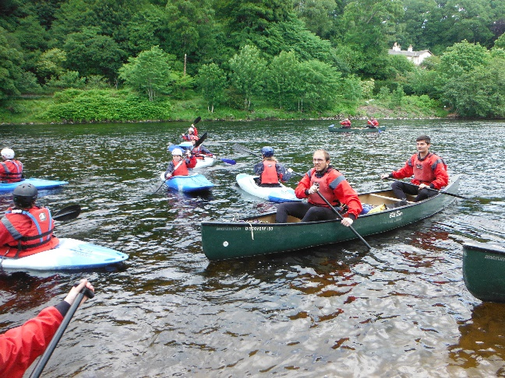
Mountain Biking  We have a large fleet of mountain bikes at the centre and once we get you a well-fitting bike and safety equipment we will head off to ride some trails. These can be a mixture of smooth and easy trails or some with jumps and drops depending on your skill level and experience.  Below is a video of one of the trails we use at Tentsmuir.  https://www.youtube.com/watch?v=VQRGSKlZwwU  By taking part in this activity, I will learn:  - About the environment and weather.  - Features that we discover on our journey.  - The wildlife of this habitat.  - How to ride a bike in a group and work together as a team.  - Learn how to use brakes and gears well and improve your bike skills.  - How to Risk Assess any dangers involved.  - How well I can listen to and follow instructions.  - How to cooperate to help each other along.  - How to overcome fears. | 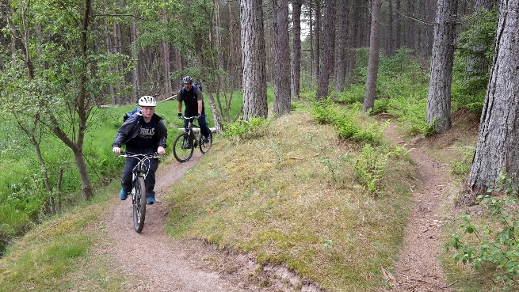
Orienteering / Geocaching  Orienteering is a fun sport that involves finding specific points using a map and clues to guide you. Once you find you marker you continue around a course back to the start.  Geocaching is similar to orienteering but you use a hand held GPS unit to find hidden boxes that contain secret stashes.  By taking part in this activity, I will learn  - How to find my way using a map and or GPS unit  - Experience the parks and hills around your area.  - How to Risk Assess any dangers involved  - How well I can listen to and follow instructions  - How to cooperate to help each other along.  - How to understand maps and GPS units. | 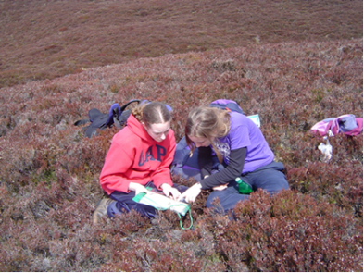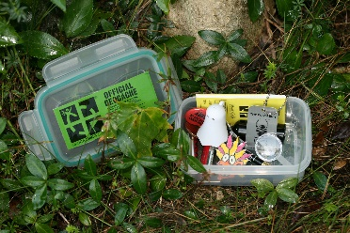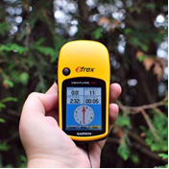
Burn Walk  A little like gorge walking, this activity involves walking up a small Burn, getting as wet as you want or staying dry. After climbing up several small falls you get the chance to slide down a natural water slide into a pool of water.  By taking part in this activity, I will learn:  - About river environment and weather  - Some natural rock features- geology.  - The wildlife of this habitat  - About working together as a team  - Leadership and responsibilities in this challenging environment  - How to Risk Assess any dangers involved  - How well I can listen to and follow instructions  - How to cooperate to help each other along.  - How to overcome fears. | 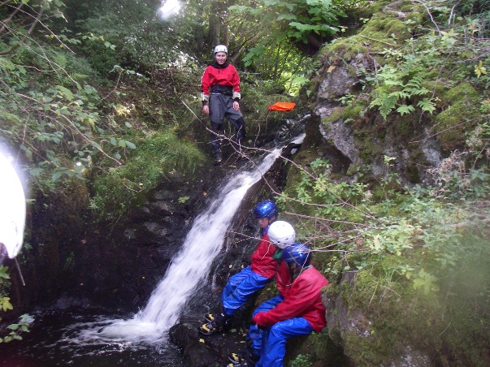
Hill walk / Adventure walk  Get to see Scotland from a different perspective. Your feet can take you places that no car can. Scotland has vast areas of wilderness and we can show you them.  By taking part in this activity, I will learn:  - About the mountain environment and weather.  - Historic facts.  - About some natural features on the rocks that we call geology.  - The wildlife of this ever changing wild habitat.  - About working together as a team.  - Leadership and responsibilities in this challenging environment.  - How to Risk Assess any dangers involved.  - How well I can listen to and follow instructions.  - How to cooperate to help each other along.  - How to overcome fears. | 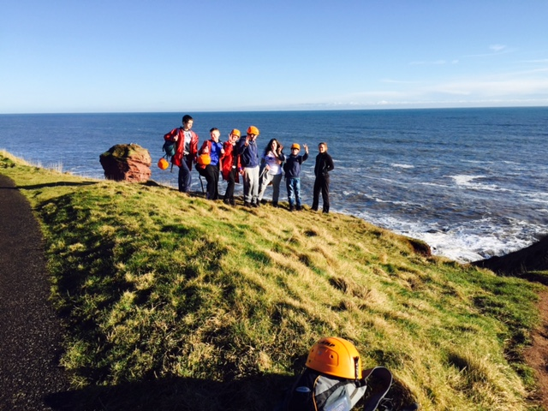  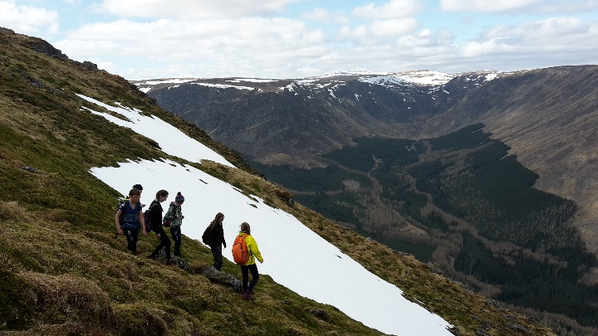
White water rafting  Make your way down the world famous Tay river in rural Perthshire on a big inflatable raft. You must work together as a team to get down safely river through some extreme rapids that include ‘the Weir’ and ‘Thistlebrig.  During this activity you will get the opportunity to learn:  - About the river environment and weather.  - The wildlife of this ever-changing wild habitat.  - About working together as a team.  - Leadership and responsibilities in this challenging environment.  - How to Risk Assess any dangers involved  - How well I can listen to and follow instructions  - How to cooperate to help each other along.  - How to overcome fears. | 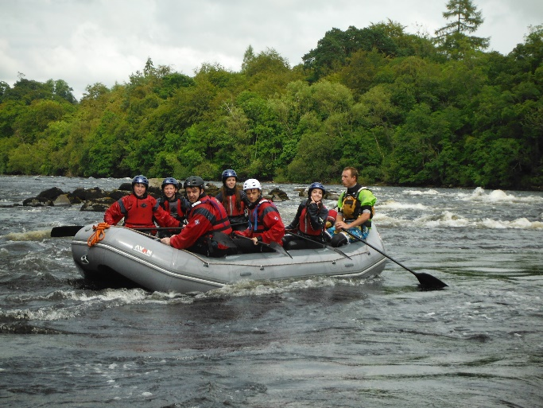
Shelter building / Bushcraft  Here’s your chance to take part in your very own ‘Bear Grylls – the island challenge’. You best quickly find materials to build a shelter and find water source and firewood. If you pass the challenge you will get the reward….’hot chocolate and maybe marshmallows.  During this activity you will learn:  - About the environment and weather.  - The wildlife of this ever changing wild habitat.  - About working together as a team.  - How to construct a makeshift shelter.  - How to light a fire safely.  - How to Risk Assess any dangers involved.  - How well I can listen to and follow instructions and act responsibly.  - How to cooperate to help each other. | 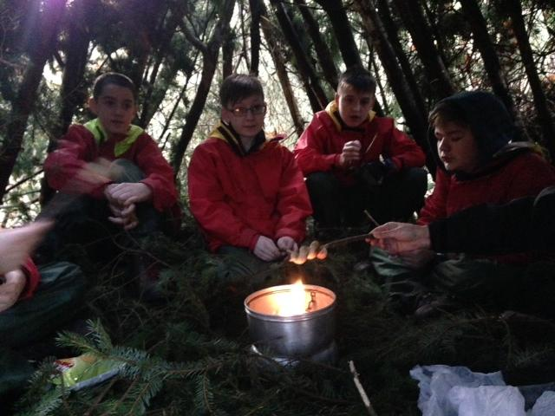
Archery  Try your hand on our Olympic style indoor target archery range or shoot outdoors using Flu-Flu arrows. This ancient sport will test your hand-eye co-ordination and concentration.  By taking part in this activity you will learn:  - About the history of archery and how the equipment is made and stored.  - How to load, aim and shoot a bow and arrow safely.  - How to Risk Assess any dangers involved.  - How well I can listen to and follow instructions and act responsibly. | 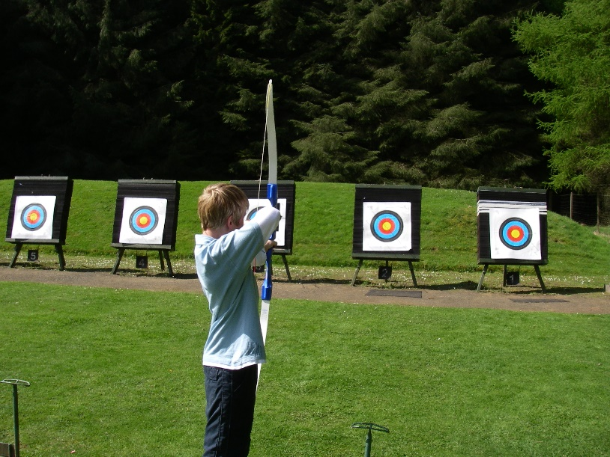
Raft Building  Construct your own floating raft and then test it out! Will you be the first team to make it out to the island and back without your craft falling apart!  During this activity you will learn:  - About the environment and weather.  - How to design and construct a raft.  - About working together as a team.  - Leadership and responsibilities in this challenging environment.  - How to Risk Assess any dangers involved  - How to cooperate to help each other along.  - How to overcome fears. | 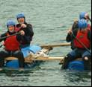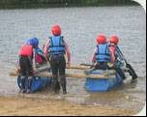
Skiing  A fun and exciting way to glide on natural snow or a man-made dry slope. We will kit you out with boots, skis etc and give you the skills you need to get down the slope safely and in control. You will start out on easy slopes progressing to steeper ones as your skills develop.  During this activity you will learn:  - About the mountain environment, snow and weather.  - How to wear and use skis, boots equipment.  - How to use your skis to slide, steer and stop yourself.  - How to use a ski lift safely.  - How to Risk Assess any dangers involved.  - How to overcome fears. | 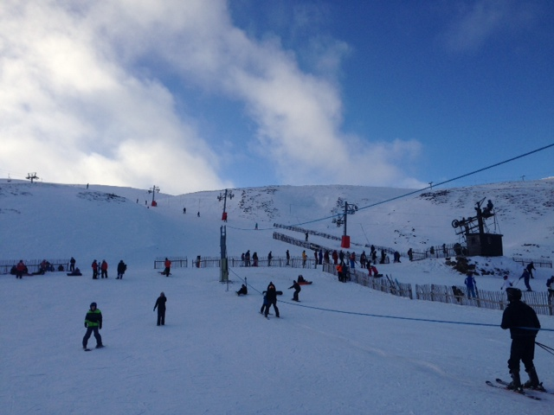
Snowboarding  We can do this on snow or on our own dry slope at the Centre. We will teach you how to get started and sliding downhill, turning and stopping using our snowboards. Snowboarding is like skateboarding on snow.  During this activity you will learn:  - About the mountain environment, snow and weather.  - How to wear and use a snowboard, boots equipment.  - How to use your board to slide, steer and stop yourself.  - How to use a ski lift safely.  - How to Risk Assess any dangers involved.  - How to overcome fears. | 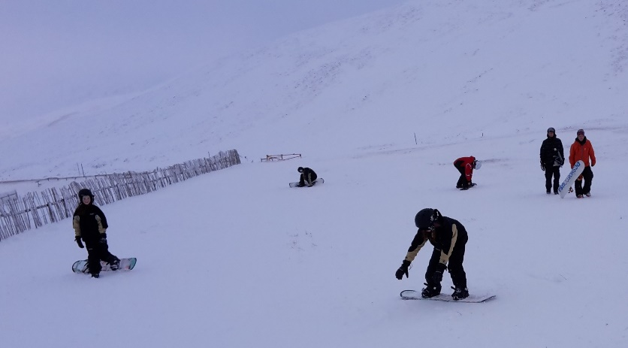
Cave Exploration / coastal walks  Exploring local Sea caves, this involves walking through a wood, and then along a beach to access Sea caves, some of them are very big others being very small. You get to explore the caves, rock pools and beach.  During this activity you will learn:  - About the coastal environment and weather.  - How erosion affects the environment.  - About geology and the formation of rock.  - How to work as a team and know about trust and responsibility.  - How to Risk Assess any dangers involved.  - How to overcome fears. | 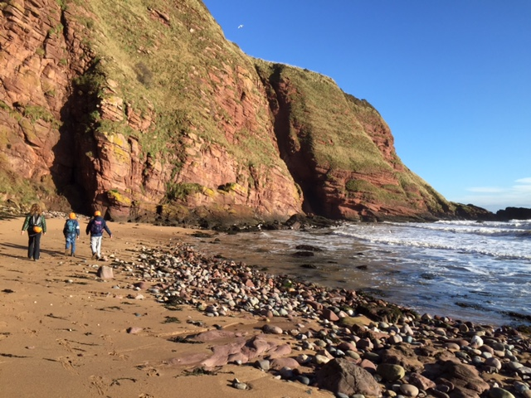
Igloo building / snow-shoeing / sledging  If we have enough snow, all the above are possible. You can construct and get inside your own igloo, sledging down a hill, or walk across the snow and not sink using snow shoes!  During this activity you will learn:  - About the mountain environment, snow and weather.  - How to design and build a snow shelter or igloo.  - How to move safely on snow or ice.  - How to use a snow saw, shovel and snow shoes.  - To work  - How to Risk Assess any dangers involved. | 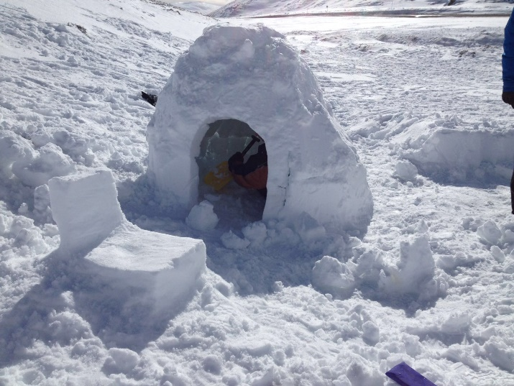
Team building / Problem solving  You will to work together to solve puzzles and physical problems. Try to think a little bit differently from the other puzzles you have tried and you’ll probably solve them. | 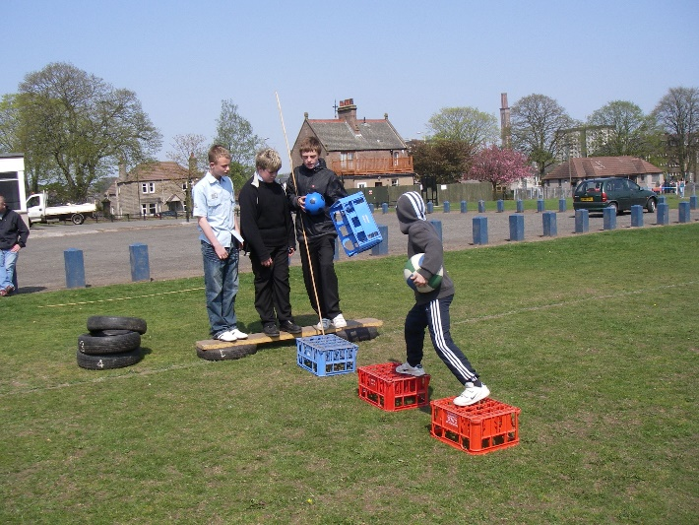
Tyrolean Traverse  You will help to set up a rope across a river or the sea and use this to get across from one side to the other.  See it in action here:  https://www.youtube.com/watch?v=6g8O_JH3s-w | 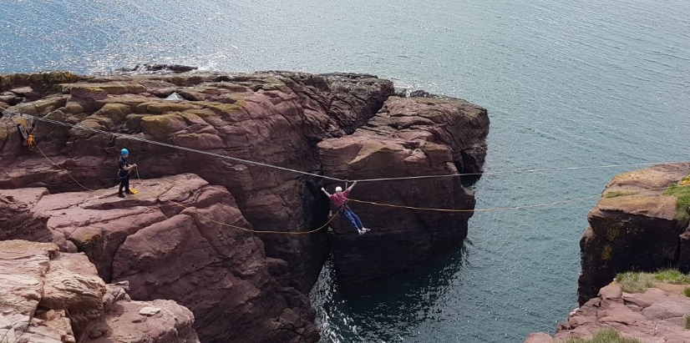
Power-Boating  This is an activity where the young people get the opportunity to see Dundee from a different viewpoint, i.e. from the river. This short activity allows the young people to explore the Estuary in a powerboat up to the bridges and across to Fife.  You can see one of our boats in the opening of our centre video here:  https://www.youtube.com/watch?v=7hgzFbllX6U | 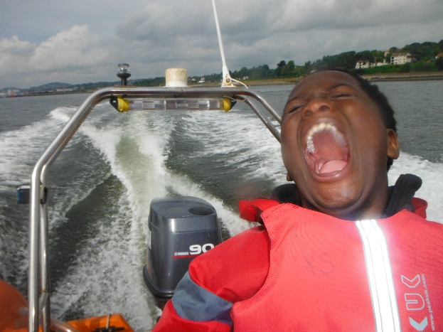
ZIP line  Have a go on our purpose built 100m Zipline. Climb to the top of the tree then slide down the wire. | PICTURE OF DW zip line
Sailing  Dundee is blessed to have a fantastic sailing venue on its doorstep. Learn the basics of how launch, sail and get your boat back to shore.  See more here:  https://www.youtube.com/watch?v=zSgCK3eIJrU | 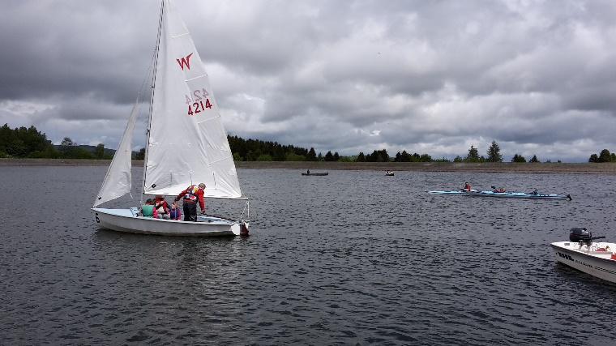

All activities are supervised by an Experienced and Qualified Instructor.

All specialist safety equipment is provided. Wetsuits, waterproofs and other protective clothing are provided where necessary.

Ancrum Outdoor Education Centre is licensed by The Adventure Activities Licence Service.  Licence No. L9681/R0396. Further information is available at www.aals.org.uk | 

