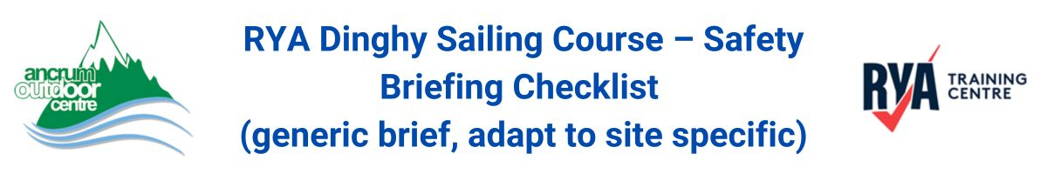
1. General Safety
☐ Introduction & Course Overview – Explain the day’s plan and learning objectives
☐ Personal Buoyancy – Everyone must wear a correctly fitted buoyancy aid at all times when on pontoon and/or slipway.
☐ Appropriate Clothing – Wetsuits/drysuits, footwear, gloves, and sun protection
☐ Helmets – If required (e.g., for high-wind conditions or younger sailors)

2. Emergency Procedures
☐ Capsize Drill – How to react, stay with the boat, righting the dinghy
☐ Man Overboard (MOB) – Procedure for retrieval and staying visible in the water
☐ Hypothermia & Cold Shock – Recognition, prevention, and response
☐ Distress Signals – Whistle, hand signals, calling for help
☐ First Aid – Location of kit and who to report injuries to

3. Sailing & On-Water Safety
☐ Weather Conditions & Forecast – Wind strength, direction, tide, local hazards
☐ Communication Signals – Hand signals, whistle use, shore-to-boat communication
☐ Right of Way Rules – Basic sailing rules to avoid collisions
☐ Staying with the Group – What to do if separated from the fleet

4. End of Briefing
☐ Confirm all participants understand safety procedures

