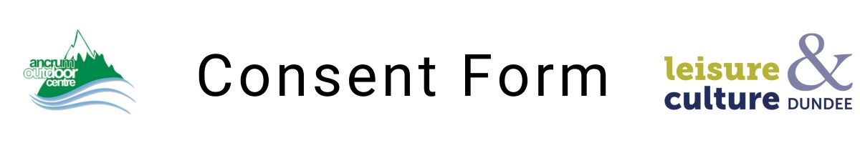
- Participant Details
Full Name:
Address:
Date of birth:
School/Group (if applicable):
Contact Tel No:
Email address:
Emergency Contact 1
Name:
Address:
Mobile:
Emergency Contact 2
Name:
Address:
Mobile:
- Medical Information
Please provide details of any medical/behavioural conditions, allergies, recent injuries, disabilities, or medication requirements or any additional support required:

Leisure and Culture Dundee will administer basic emergency first aid in accordance with the relevant medical authorities. This will exclude administration of ALL medicines, excepted agreed use of EpiPen. By signing this consent, you agree to your child receiving any treatment considered necessary by attending medical authorities.

- Data Protection and Photography
- Information on this form will be held in accordance with the UK GDPR and Data Protection Act 2018 and used solely for the safe delivery of activities.
- Do you consent to photographs/videos being taken for promotional/educational purposes?
 | Yes ☐ | No ☐
- Consent and Acknowledgement of Risk
Adventure activities (such as climbing, abseiling, coasteering, mountain biking, and water-based activities) involve an element of risk. Activities are delivered under the requirements of the Adventure Activities Licensing Regulations 2004, supervised by trained and qualified instructors, and in compliance with UK Health & Safety Legislation.
- Risks are managed to an appropriate level; however, participants may still be exposed to risk of accident, injury or loss
- By signing this form, you acknowledge and accept these inherent risks
- You accept our terms and conditions https://www.ancrum.com/terms-business.
- Declaration of Parent/Guardian (if under 18)
I consent to my child’s participation in activities with Ancrum Outdoor Centre. I have provided full details of any relevant medical/behavioural conditions and understand the nature of the activities, their risks, and the responsibilities of both organisers and participants. I also declare that they are fit to take part in physically demanding outdoor activities.
*** This section must be signed and dated ***
Parent/Guardian Name:
Signature:
Date:
- Adult Participant Declaration (if 18 or over)
I confirm that I have read and understood this consent form, and I am fit to participate in the planned activities.
Participant Name:
Signature:
Date:

